***Task 2***

**Execute the following network commands like ipconfig, tracert, telnet, netsh, ping, nslookup, netstat:**

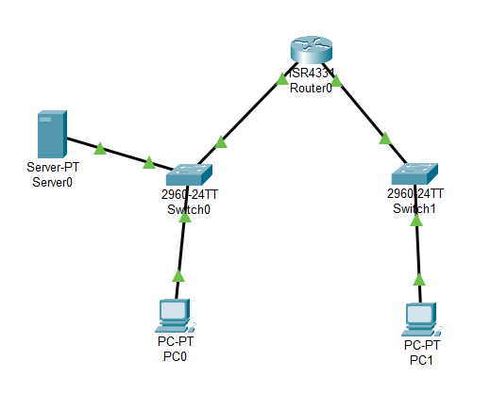

***Step 1:*** Launch Cisco Packet Tracer

Double click the Cisco Packet Tracer icon on your desktop or find it in your applications list and open the program

***Step 2:***Create a simple network topology

***1. Add devices***

Routers and Switches

Drag and drop a router and a switch from the device list on to the workspace

PC’s

Drag and drop 2 PC’s on to the workspace

***2. Connect devices***

Use the connection tool to connect the devices

Connect 1st PC to the switch using the Copper Straight-Through cable

Connect the switch to the router using another Copper Straight-Through cable

Connect the 2nd PC to the switch using Copper Straight-Through cable

// Connect the switch to the router using another Copper Straight-Through cable

***3. Configure devices***

Configure the router

Click on the router, go to config tab, assign IP addresses to the router interfaces

***Ex:*** PC0: Interface G0/0: IP address 192.168.1.1

Subnet Mask: 255.255.255.0

***Ex:***PC0: Interface G0/0: IP address 192.168.2.1

Subnet Mask: 255.255.255.0

Configure the PC’s

Click on each PC, go to the desktop option, and then IP configuration

Assign IP addresses to each PC

***Ex:*** PC0: IP address 192.168.1.2

Subnet Mask: 255.255.255.0

Default Gateway: 192.168.1.1

***Ex:***PC1: IP address 192.168.2.2

Subnet Mask: 255.255.255.0

Default Gateway: 192.168.2.1

***4. Execute networking commands***

* Click on a PC0
* Go to the ***Desktop*** tab and open the***Command Prompt***

***1.ipconfig:***

This command displays all current TCP/IP network configuration values and refreshes DHCP and DNS settings.

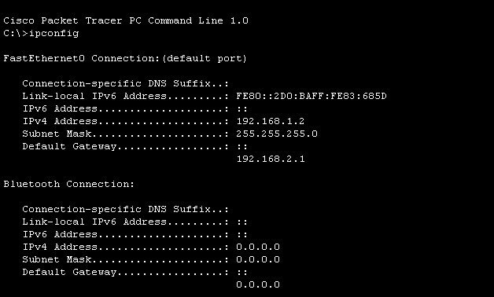

***2. tracert:***

This command traces the path taken to a destination by sending ICMP Echo Request messages.

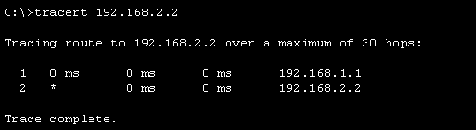

***3. telnet:***

This command is used for interactive communication with another host using the Telnet protocol.

telnet <destination IP> <port>

1. ***Assign IP Address:***

* Click on the router.
* Go to the **Config** tab
* Select the interface connected to the switch (eg., G0/0)
* Assign IP address: 192.168.1.1, Subnet Mask: 255.255.255.0

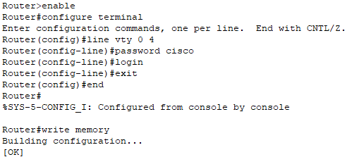

***Telnet from PC to Router***

1. ***Open Command Prompt:***

* On the PC0, go to the***Desktop*** tab and open the***Command Prompt****.*

1. ***Execute Telnet Command:***

**telnet <destination IP> <port>**

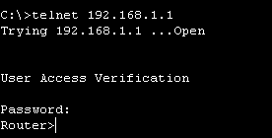

***4.Router configuration and Brief Ip Interface***

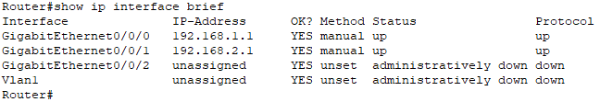

***5. Ping 192.168.2.2***

**ICMP Echo**

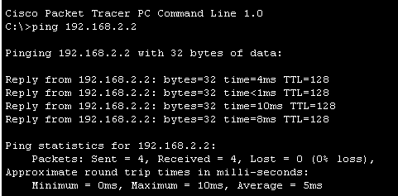

***6. nslookup***

**nslookup [www.google.com](http://www.google.com)**

***Configure the DNS Server***

1. ***Assign IP Address:***

* Click on the server.
* Go to the **Config** tab and select the **FastEthernet0** interface.
* Assign IP address: 192.168.1.3, Subnet Mask: 255.255.255.0, Default Gateway: 192.168.1.1

***Configure DNS Server***

* Go to the **Services** tab on the server.
* Select **DNS** and turn the service **On**.
* Add an entry for [www.google.com](http://www.google.com) with an IP address (e.g., 8.8.8.8)

***Use the nslookup Command***

1. **Open Command Prompt on PC0:**

Go to the **Desktop** tab on PC0.

Open the **Command Prompt.**

1. **Execute the** nslookup **Command:**
2. **nslookup [www.google.com](http://www.google.com)**

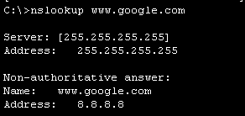

***7. Netstat***

